**Traditional Machine Learning Algorithms and Basic Neural Networks**

**Introduction**

Machine Learning (ML) encompasses a broad range of algorithms designed to enable computers to learn from data. Traditional ML algorithms and basic neural networks differ fundamentally in their architecture, capabilities, and suitable application scenarios. Understanding these differences is essential for selecting the appropriate approach for a given problem, especially as Deep Learning (a subset of neural networks) has gained prominence for complex tasks.

**Traditional Machine Learning Algorithms**

**Characteristics:**

* **Feature Engineering:** Require manual feature extraction and selection. The quality of input features heavily influences model performance.
* **Model Complexity:** Generally, involve simpler models such as linear regression, decision trees, support vector machines (SVMs), k-nearest neighbours (kNN), and ensemble methods like random forests.
* **Interpretability:** Often more transparent and interpretable; for example, decision trees and linear models allow insight into decision boundaries.
* **Data Requirements:** Typically perform well with smaller datasets, provided features are well-engineered.
* **Training & Computation:** Usually faster to train and computationally less intensive compared to neural networks.

**Limitations:**

* Struggle with high-dimensional, unstructured data such as images, audio, or text.
* Limited capacity to model complex, non-linear relationships without extensive feature engineering.

**Basic Neural Networks**

**Characteristics:**

* **Automatic Feature Learning:** Capable of learning hierarchical feature representations directly from raw data.
* **Model Complexity:** Comprise interconnected layers of neurons that can model complex, non-linear relationships.
* **Data Requirements:** Usually require large amounts of data to avoid overfitting and to fully leverage their capacity.
* **Training & Computation:** More computationally intensive due to iterative optimization and large parameter counts.

**Limitations:**

* Less interpretable than traditional models.
* Prone to overfitting if not properly regularized.
* Require significant computational resources and tuning.

**Key Differences**

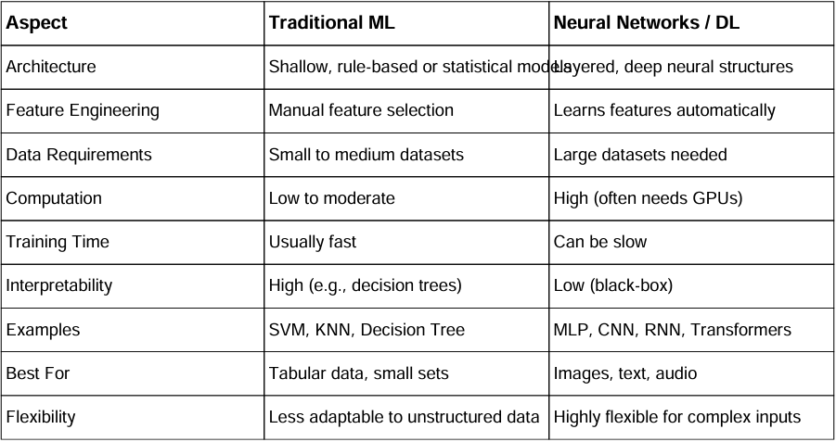

**Scenarios Where Deep Learning Offers Significant Advantages**

1. **Unstructured Data Processing:** Tasks involving images, audio, and text—such as image recognition, speech transcription, and natural language understanding—are where deep neural networks outperform traditional models due to their ability to automatically learn hierarchical features.
2. **High-Dimensional Data:** When datasets contain thousands or millions of features, deep learning models can effectively capture complex, non-linear relationships that traditional algorithms may struggle with or require extensive feature engineering.
3. **Complex Pattern Recognition:** Tasks like facial recognition, object detection, and machine translation benefit from deep learning’s capacity to model intricate patterns and dependencies.
4. **End-to-End Learning:** Deep neural networks enable end-to-end training, directly mapping raw inputs to outputs, reducing the need for manual preprocessing and feature engineering.